**Design a real time system**

We have 5 tasks as follows: -

Task_Name {Periodicity, WCET, Deadline, Priority}

1. Temp read {10ms , 2.5ms , 10ms , 5 }
2. Blood pres {25ms , 3 ms , 25ms , 4 }
3. Heart beat {100ms, 1.5ms, 100ms, 3 }
4. Alert Siren {5 ms, 1 ms , 8ms , 2 }
5. Touch LCD {100ms , 2ms , 100ms , 1 }

* Hyperperiod = 100ms.
* CPU load = 63.33%
* Tick rate = 5 ms to fit with Blood, temp tasks whose periodicities are 10 and 5 ms.

**Note:** ***Sensors*** (tasks 1, 2 &3) are higher priority than ***Alert*** task to not miss any sensor read data.

**Note:** Touch LCD task is the least priority because its dead line is not time-critical.

Manual Timeline

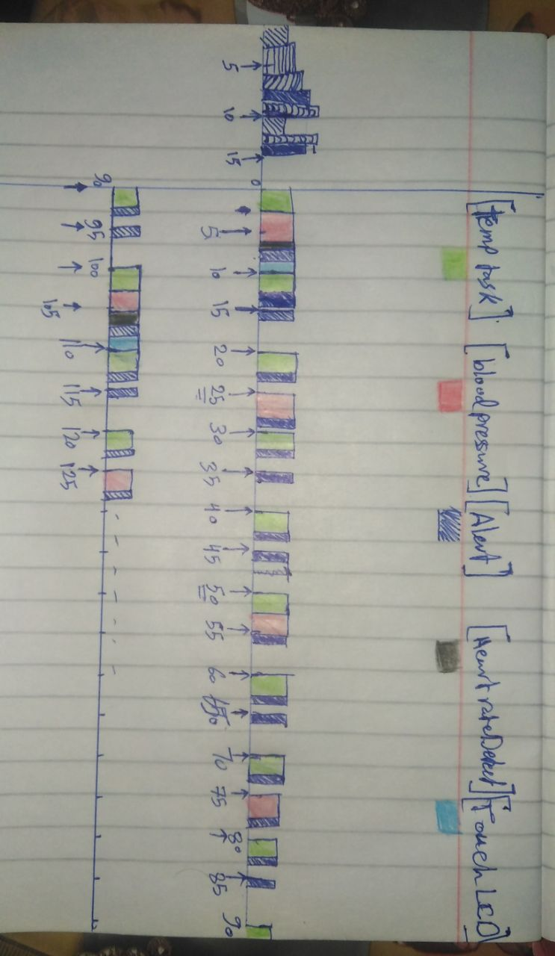

* CPU load = Execution time of all tasks / Hyperperiod (100ms).
* Execution time = 2.5*10 + 3*4 + 1.5*1 + 2*1 + 1*20 = 60.5 ms.
* CPU load = 60.5/100 = 60.5%.
* **Note:**  if the system is not safety critical, we can reduce CPU load by increasing the periodicity of **Alert task** to 10 ms but Alert task will take the readings of Blood pressure at 25, 75,125… at 32.5, 82.5, 132.5…. respectively.

In this case the CPU load will be 50.5%

**Model the system in SimSo**

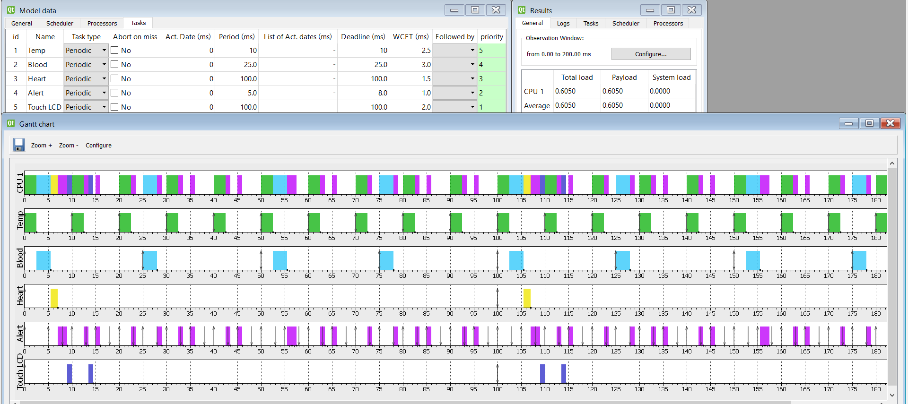

The system is schedulable because all tasks are finished before their deadlines.

The system is not loaded (60.5 % CPU load).